1. **FOUNDATIONAL PROGRAMMING CONCEPTS (INTRODUCTION AND REVIEW)**

**INTRODUCTION TO THE ALGORITHM**

* ***Described in different ways:***
* Well-defined procedure that allows an agent to solve a problem
* Clear and unambiguous specification of steps needed to solve a problem
* Precise “recipe” of solving a problem, so there must be "ingredients" and steps to solve the problem
* Procedure for solving a problem in terms of the actions to be executed and the order in which those actions are to be executed; agent is a computer or a robot
* ***An algorithm must:***
* Be well-ordered and unambiguous;
* Have every operation effectively computable; and
* Terminate

**ELEMENTS OF AN ALGORITHM**

* ***Variables***
* Named memory location that can store a value
* Box into which one can store and value, and from which one can retrieve a value
* Only one value is meant to be stored by box
* Type of value to be placed on the box usually depends on the size of the memory
* ***Operations***
* Action that allows the manipulation of one or more variables
* Allow for the program to fulfill its goals and end the program
* Types:
* Primitive (input, assignment, output)
* Conditional
* Looping

**PROBLEM ANALYSIS – CREATING ALGORITHMS**

* **Problem:** The radius of a circle is equal to one unit. Compute the corresponding area of a circle and print out the value of the area.
* **Problem Analysis:**
* Input: radius, pi
* Process: area= radius*radius*pi
* Output: area

**EXPRESSING ALGORITHMS**

* **NATURAL LANGUAGE**
* Language that a human would be able to read, write, speak, and understand
* Whatever language rules that the language has is followed in the creation of the algorithms
* Characteristics:
* Most understandable, regardless of the IT level
* Allows for the detail necessary for an algorithm
* Can also be quite vague at times
* Humans typically use their natural language which at times can be too rich, ambiguous, and will depend on the language
* Example:
* Define the value of radius r and pi (3.1416)
* Calculate the area of the circle, area = r *r * pi
* Print out the radius and the computed area
* **PROGRAMMING LANGUAGE**
* Comprises of words, statements, and rules to produce different types of machine output
* Construction is very similar to a natural language but has lesser ambiguity
* Characteristics:
* Not recommended due to how rigid the rules of a programming language is
* When solving a problem, it is best to be able to think at a certain abstract level so that more options can be explored
* Shifts the emphasis of how to solve the problem to tedious details of syntax and grammar
* **PSEUDOCODE**
* Algorithm in a natural language, but structured to look more like a programming language
* Artificial and informal language that helps programmers develop algorithms
* Characteristics:
* Simple, readable, has very little rules, and doesn't worry much about details like punctuation
* Allows one to think at an abstract level about the problem
* Contains only instructions that have a well-defined structure and resemble programming languages
* Example:
* NUMBER r, area.
* INPUT r.
* area=3.14*r*r.
* OUTPUT area.
* **FLOWCHARTING**
* ***Flowchart***
* Picture of the separate steps of a process which is usually presented in a sequential order
* Generic type of tool that can visually express an algorithm
* ***Flowcharting***
* Process of creating the flowchart
* Can also include the problem analysis

1. **BASIC PROGRAMMING**

**WHAT IS PYTHON?**

* It is an interpreted, object-oriented, high-level programming language with dynamic semantics.

**“interpreted”**

* "It is where the source code is not directly translated by the target machine"

**“object-oriented”**

* "It is a computer programming model that organizes software design around data, or objects, rather than functions and logic."

**“high-level programming language”**

* "It is any programming language that is user-friendly for programming and is generally independent of the computer's hardware architecture"

**“dynamic semantics”**

* "It is an approach to defining where pieces of text are viewed as instructions to update an existing context, the result of which is an updated context."

**PRINT COMMAND**

* Syntax:
* print (<add something here>)
* print (‘hello world’)
* output: hello world

**VARIABLES**

* Variables are names that can be assigned a value and then used to refer to that value throughout your code
* Declaring/Summoning/Creating/Using/Syntax:
* <variable name> = <value>
* student_id = 123456

**RULES OF VARIABLE NAMING**

1. Can be as long or as short as you like
2. May contain uppercase and lowercase letters
3. (A – Z, a – z), digits (0 – 9), and underscores (__)
4. Start with a letter or the underscore character
5. Variable names are case-sensitive (must be
6. named or referred to in the identical fashion)
7. Use very descriptive names

**VARIABLE NAMING CONVENTIONS**

* Camel Case naming convention
* myAge
* favColorInTheColorWheel
* Pascal Case naming convention
* MyAge
* FavColorInTheColorWheel
* Snake Case naming convention
* my_age
* fav_color_in_the_color_wheel

**VARIABLE DATA TYPES**

* Are the things/values that a variable can have:
* These are:
* Integer
* Floating Point
* String
* Boolean
* Null

**INTEGERS**

* These are zero, positive, negative, whole numbers.
* There is no explicitly defined limit in the value of the integer Python.
* student_id = 123456

**FLOAT**

* This represents a floating-point number.
* They are represented with a decimal point.
* x = 9.9999999999999
* You can also make use of negative values for the floating-point number.
* x = - 73.435
* student_id = 1.2345

**STRING**

* Strings are a sequence of bytes representing Unicode characters.
* There are several ways to create a string.
* They differ based on the delimiters and wether a string is single or multiline.
* student_id = ‘meing123’
* **Concatenation** (“+”)
* Can be used to stitch together strings and values

**STRING DELIMITTER**

* Can use double quotes ("<any>") or single ('<any>') quotes
* Is useful for creating sentences containing single quotes
* To get around this, the "\" can be used.
* For longer strings, you can use the triple quotes ("'<any>'")

**BOOLEAN**

* Boolean data types determine the truth value of expressions.
* They can either be True or False.
* booleanVal = True
* print(booleanVal) # Outputs True

**NULL**

* This type is used to define a null variable or object.
* It makes use of the “None” keyword.
* We can assign “None” to any variable.
* It can also be used in Expressions.
* emptyVal = None
* print(emptyVal) # Outputs None

1. **Error and Exception Handling**

**Code Block**

* A block is a piece of Python program text that is run as a unit.
* A block is a smaller component of your program.
* Imagine it as beginning of a bigger command and the end.
* Code blocks are identified by their indentation in Python.

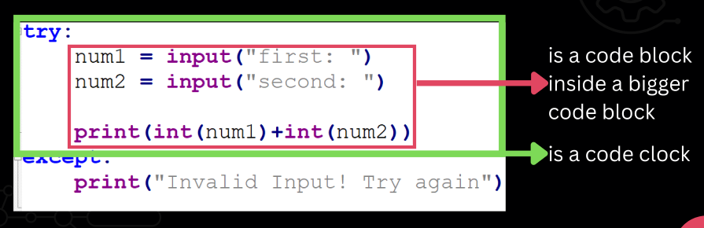

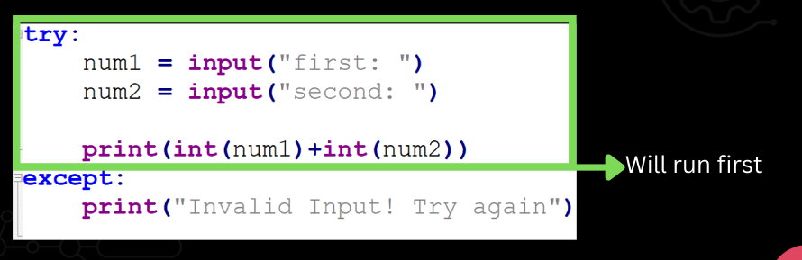

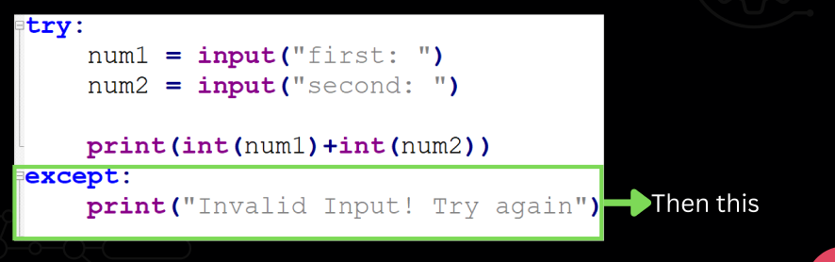

**What can we conclude:**

* In Python, the code is sequential
* It is modelled after a waterfall
* The code is read from top to bottom, from major code block to a minor code block one at a time.

**What if we don’t indent?**

* Error

|  |  |  |  |  |
| --- | --- | --- | --- | --- |
| False | await | else | import | pass |
| None | break | except | in | raise |
| True | class | finally | is | return |
| and | continue | for | lambda | try |
| as | def | from | nonlocal | while |
| assert | del | global | not | with |
| async | elif | if | or | yield |

* Never use keywords or commands to name your variables.

**EXCEPTION**

* It is an unwanted or unexpected event when a computer program runs.

**EXCEPTION HANDLING**

* It is the process of responding to unwanted or unexpected events when a computer program runs.
* When exceptions occur, the Python interpreter stops the current process and passes it to the calling process until it is handled. If not handled, the program will crash.

**TRY…**

* In Python, exceptions can be handled using “try” statement.
* The critical operation which can raise an exception is placed inside the try clause.

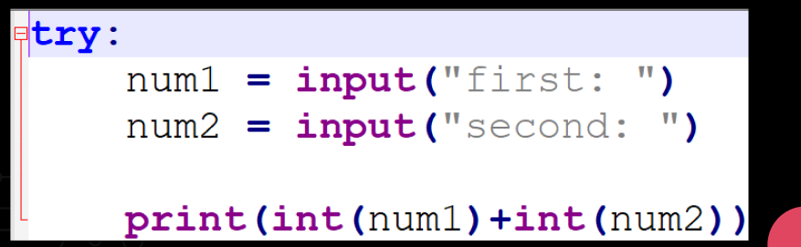

**z**

* The code that handles the exceptions is written in the except clause.
* We can thus choose what operations to perform once we have caught the exception.

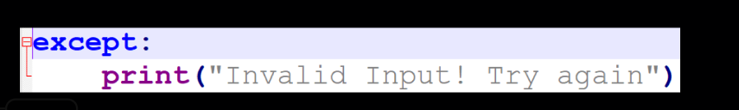

**TRY … EXCEPT**

* Creates a block of code
* “Try” indents those proceeding after it until “Except” or another one of its optional keyword pair is used.

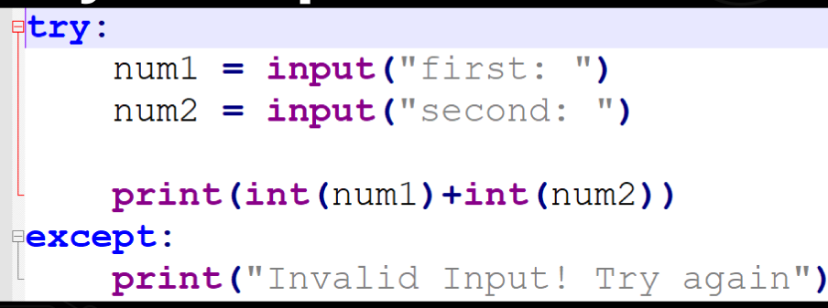

**TRY… ELSE**

* You can use the optional “else” keyword with the try… except statement
* You may use this if you want code to run after the “try” statement did not have an error

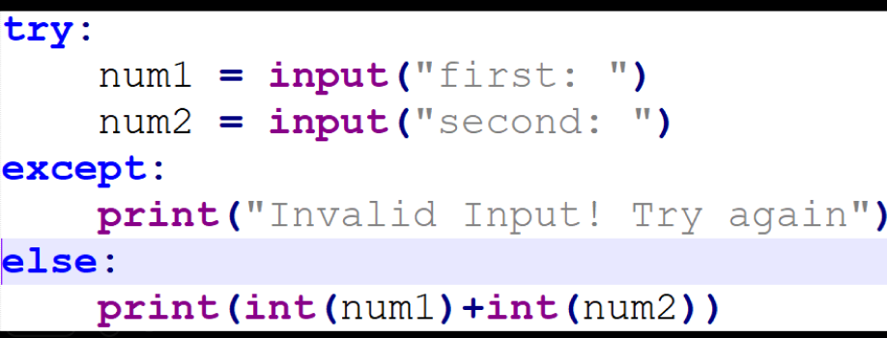

**TRY … FINALLY**

* The try statement in Python can have an optional finally clause.
* This block is executed no matter what, and is generally used to release external resources.

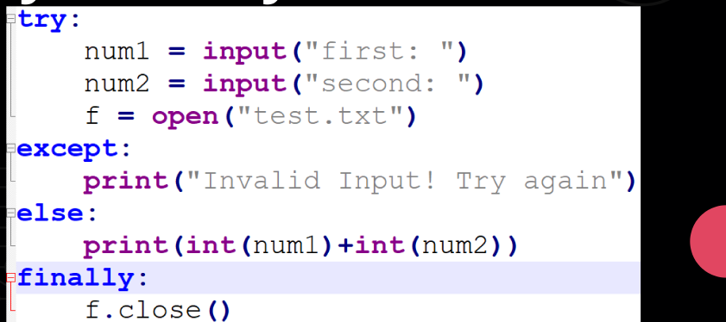

SYNTAX:

try:

<content>

except:

<what happens when exceptions occur>

<else:>

<code to run if no exception in try>

<finally:>

<code to run even if exception is done in try>

1. **Error – Syntactic (Grammar/ Spelling)**

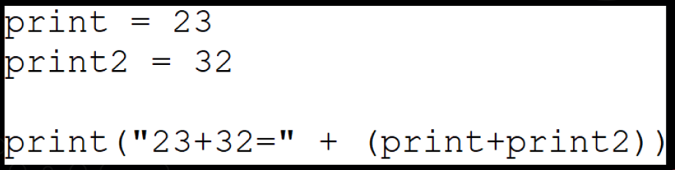

1. **3+3**3/(8*2)*4**

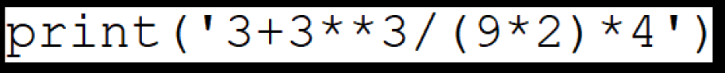

1. **Error – Syntactic (Grammar/ Spelling)**

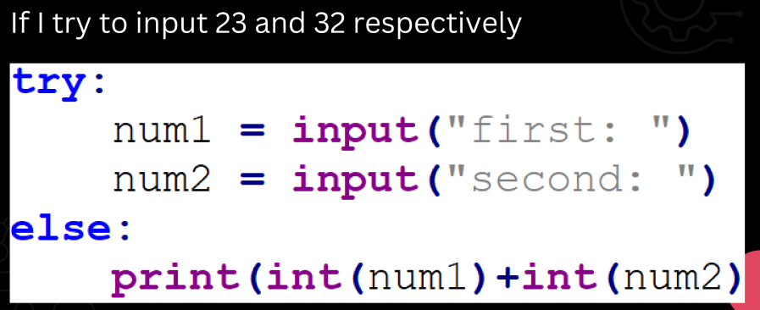

1. **Error – Semantic (Meaning/ Command)**

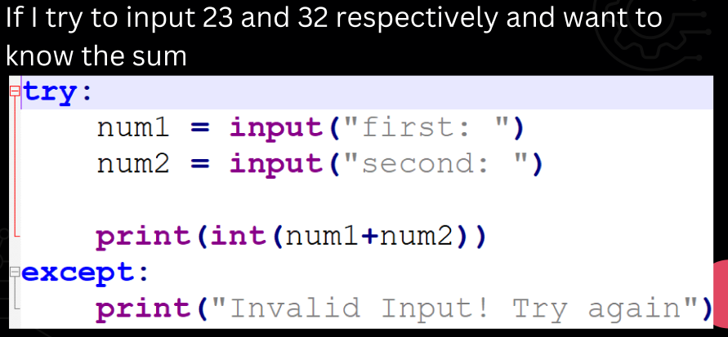

1. **Error – Syntactic (Grammar/ Spelling)**

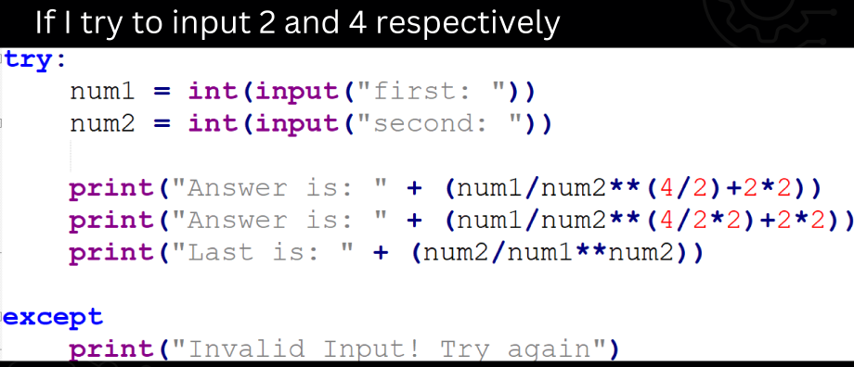

1. **CONDITION AND SEQUENCE**

**DATA STRUCTURES**

* It is an organized storage used to keep data

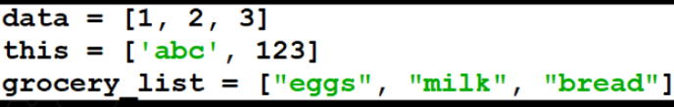

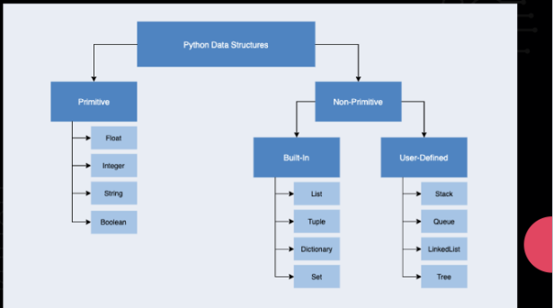

* An index refers to a position within an ordered list
* Think of it as some sort of location in a map
* For the built-in linear data structures. Think of it like how you number your quiz answers.

**LISTS**

* It has an order (index 0 to n)
* May be a mixture of data types
* Items can be updated/overwritten

**SYNTAX WHEN CREATING**

* <list_name> = [<content1>, <content2>]

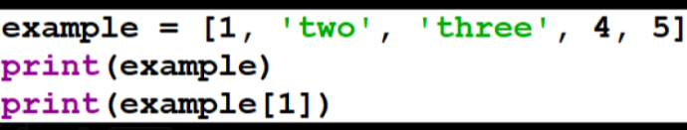

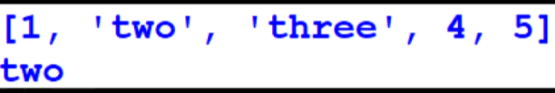

**SYNTAX WHEN REFERENCING ITEM**

* <list_name>[<index>]
* Example

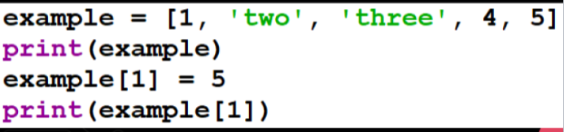

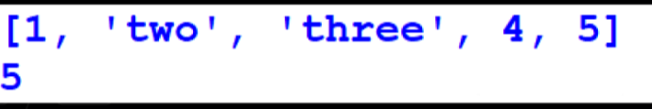

**CONCLUSION**

* Lists are created the same way as variables, just with squares brackets
* You can change the values of anything in the list
* We use indexes to refer to items in the list

**TUPLE**

* It has an order (index 0 to n)
* May be a mixture of data types
* Items, once tuple is created, cannot be updated/overwritten

**SYNTAX WHEN CREATING**

* <tuple_name> = (<content1>, <content2>]

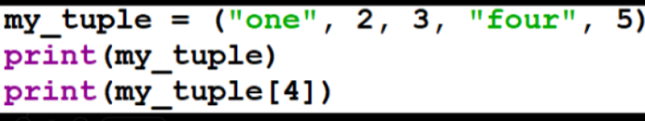

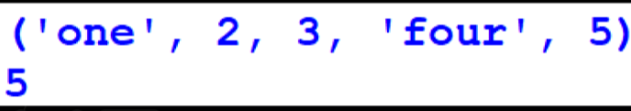

**SYNTAX WHEN REFERENCING ITEM**

* <tuple_name>[<index>}

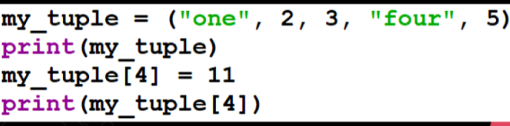

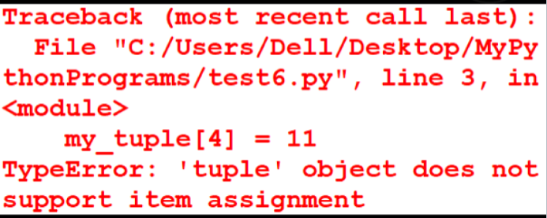

**CONCLUSION**

* Tuples are created the same way as variable, just with parentheses
* You cannot change the values of anything in the tuple
* We use indexes to refer to items in the tuple

**SET**

* It has no order
* May be a mixture of data types
* There can be no duplicate values, all items are unique
* Items can be overwritten/updated

**SYNTAX WHEN CREATING**

* <set_name> + set([<val1>, <val2>])
* Example

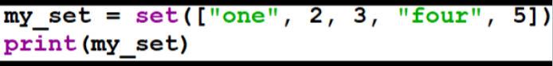

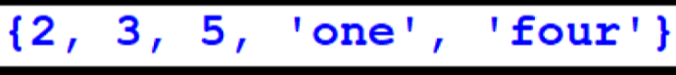

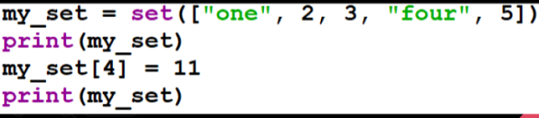

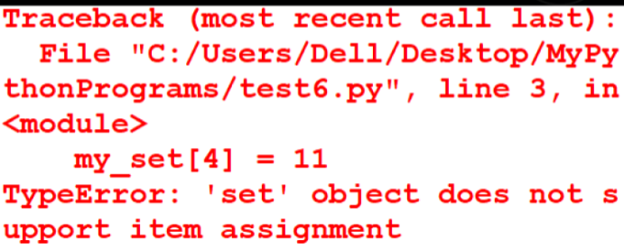

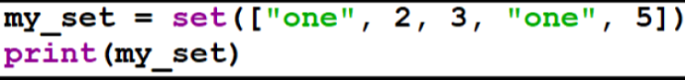

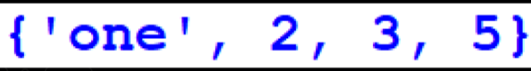

**CONCLUSTION**

* Presenting sets are done as a whole, they have no indexes assigned
* Sets sort themselves
* Sets unify duplicate values

**DICTIONARY**

* It is ab unordered collection of data values (no indices)
* Dictionary holds the key: value pair
* Can use varied data types as key-value pairs

**SYNTAX WHEN CREATING**

* <dictionary_name> = {<key1>: <value1>, <key2>: <value2>}



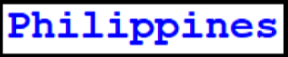

**SYNTAX WHENN REFERENCING ITEM**

* <dictionary_name>[<key>]





**CONCLUSION**

* Key-value pairs matter
* We may reference a key-value pair only by using the key
* Dictionaries use curly braces

**REVIEW TABLE**

* Fill In the following table in regards to the characteristics of the discussed Built-in Python Data Structures